**Project – Kiran Finance Report**

* This project is to build a personal finance dashboard.
* First step is to collect data. I record my every day expenses in google sheets as it is a cloud-based storage and easily accessible.
* I created relevant lookup tables from my previous experience and recorded data in data tables.
* Relevant lookup tables are:

For Income Table:

* + Date
  + Source of income
  + Account (Credit)

For Expense Table:

* Date
* Account (Debit)
* Expense category
* Expense sub-category
* Once data collection was done in Google sheets, I connected the sheet to Power BI Desktop to process and create visualization.
* Using Power BI Query editor, I cleaned, processed and transformed the data as required. Then extracted relevant data from the existing table. Finally created a visualization to display the totals and trends from the data.
* Totals and KPIs:
  + What are the total expenses, income and investments for the year?
  + What are the current balances in each of the account?
  + What are the monthly expenses, income and investments?
  + Credit card usage in a Month.
  + Find the expenses by category and sub-category.
  + Find the transactions made for each Sub-category.
  + Find the top expense for the Month.
  + Compare the Category wise expense with the Budget and provide the % of expense over budget.
  + What is the income through salary?
  + Total investments for the month over the income earned.

**Google Sheets Data Collection**

* To collect finance data, I have used Google sheets.
* I have created separate sheets for the following tables:
  1. Last Balance – Lookup Table
  2. Account – Lookup Table
  3. Income Category – Lookup Table
  4. Income Sub Category – Lookup Table
  5. Expense Category – Lookup Table
  6. Expense Sub Category – Lookup Table
  7. Income Data – Facts Table
  8. Expense Data - Facts Table
* I have created unique keys for Lookup tables.
* For filling in data in Facts table I wanted dropdowns. For example, I’m recording an expense for a movie. I want to select “Entertainment” from the Expense Category. Once I select my expense category, I want the dropdown for corresponding Expense Sub Category. For this I had to create a separate drop downs sheet as follows.
  1. For the *Category dropdown* in Facts Table, went to Data -> Data Validation. Created data validation rules where criteria was “Dropdown (from a range)”. The range was the Category names from Category Lookup tables.
  2. In the “Drop Downs” sheet, I have taken the Sub Category table. Based on the corresponding Category Key, I have pulled in the Category names from Category Lookup tables using **XLOOKUP**.

**=XLOOKUP(B2,'Expense Category'!A$2:A$14,'Expense Category'!B$2:B$14)**

* 1. I had to filter the Sub Category’s based on the select of Category in Facts table. For that, I had to use the following method using **ARRAYFORMULA** and **BYROW** functions.
* To pull in the Category selected in facts table, I used below function to get the Category data for that entire column range as I enter new data.

**=ARRAYFORMULA('Expense Data'!D2:D)**

* To fetch the corresponding Sub Category, I used below functions to get Sub Category’s as a rows. BYROW function helps to apply LAMBDA function to filter out sub category for the range of category pulled by ARRAYFORMULA function.

**=BYROW(E2:E,LAMBDA(X,TRANSPOSE(UNIQUE(FILTER(A2:A,C2:C=X)))))**

* 1. Once the Sub Categories are filtered out, in the facts table, once again I created data validation rules for *Sub Category dropdown* where criteria was “Dropdown (from a range)” from the row of Sub category filtered out in dropdown sheet.
  2. Similarly, data validation rule was created for *Account dropdown* using range from Account Lookup table.
* I wanted the *Sub Category Keys* and *Account Keys* in my Facts table as I will be requiring only these keys to work in Power BI. I used XLOOKUP with IFERROR function to pull data from lookup tables.

**=IFERROR(XLOOKUP(E2,'Expense Sub Category'!B$2:B$55,'Expense Sub Category'!A$2:A$55,NA,0),"")**

**Power BI Report Generation**

**Connecting & Shaping Data:**

* I have created a blank report in Power BI Desktop with name “Kiran Finance Report 2025.pbix”
* I connected for data using google sheets URL and signed in using my credentials.

* I selected the necessary sheets and transform data.

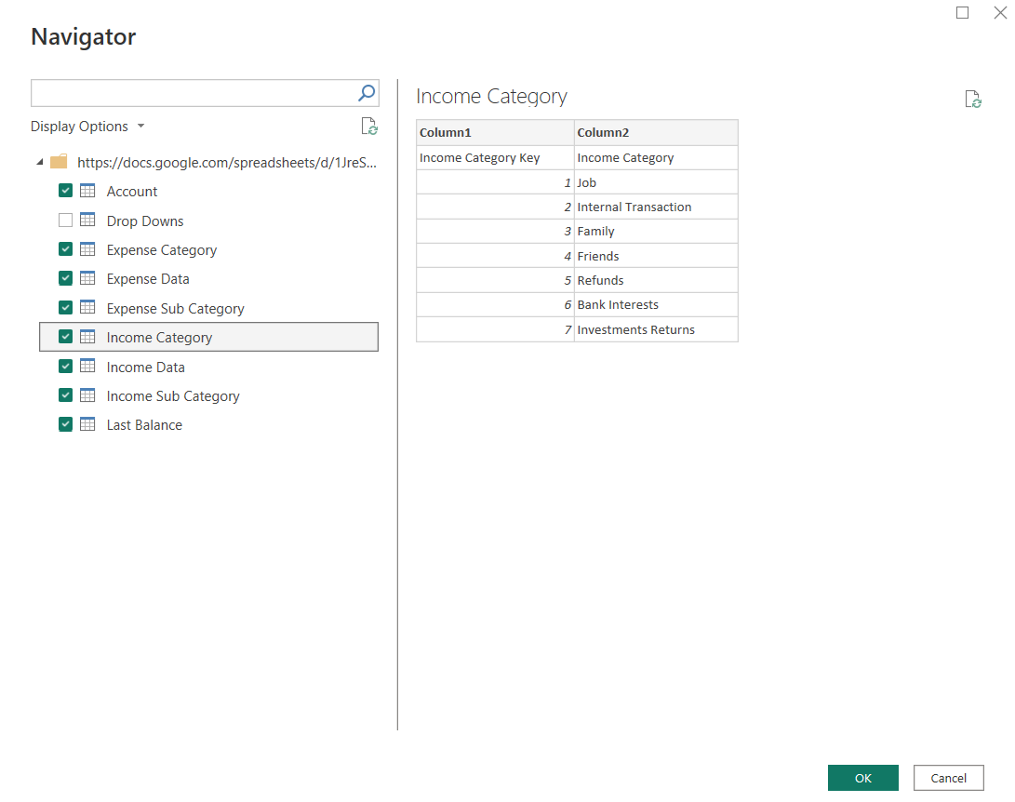

* I promoted headers, updated data types, and loaded the tables. Then data quality was verified using the “data preview” option from the “View” tab. I checked “column quality”, “column distribution” & “column profile”. This helped in validating the unique values in lookup tables. I removed/filtered errors/NA values if any.

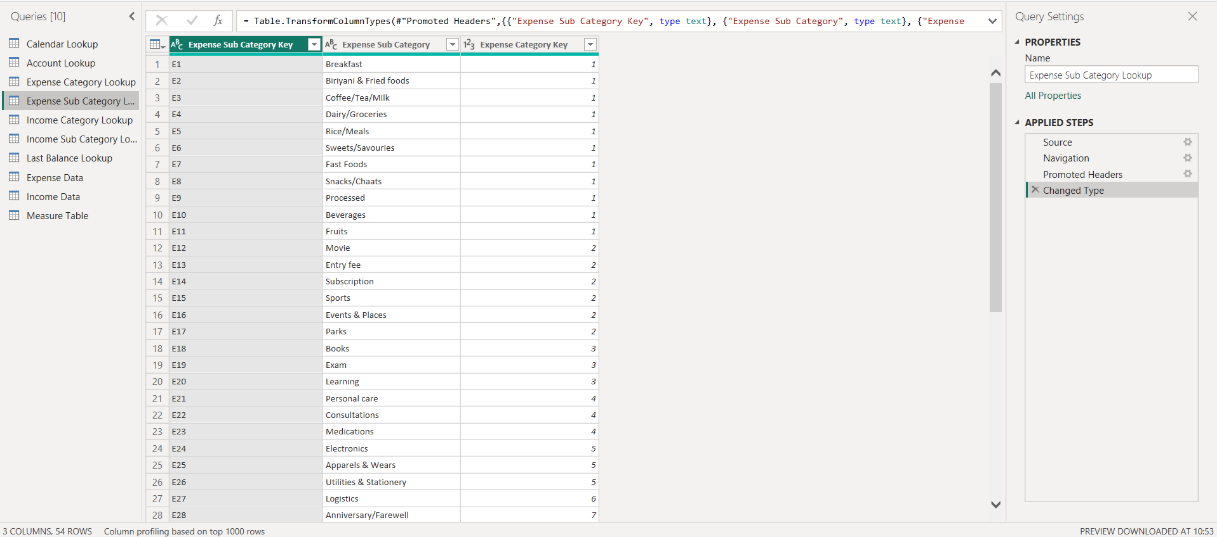

* I created rolling calendar using blank query in power query and extracted month, year, etc.

* I disabled “Include in report refresh” option for all lookup tables except Calendar Lookup.

**Data Modeling:**

* Table relationships were created between fact tables and lookup tables based on primary keys and foreign keys. I have incorporated **Snowflake Schema**. All relationships were 1 to many and filter flowing downstream. I disabled lookup tables from report refresh load. I also hide foreign keys in report page.

**Calculated Fields with DAX:**

* I created a blank table for measures. I created measures as below. These are some important measures which I used. More measure was created as the dashboard became more sophisticated.

|  |  |
| --- | --- |
| Total Expense | Total Expense = **SUM**(  'Expense Data'[Expenditure]) |
| Total Income | Total Income = **SUM**(      'Income Data'[Income]) |
| Total Investments | Total Investments = **CALCULATE**(      [Total Expense],      'Expense Sub Category Lookup'[Expense Sub Category] = "Investments") |
| Balance | Balance = [Total Expense] - [Total Income] |
| Account1 Balance | IDBI Balance = **CALCULATE**(      #### - [Balance],      'Account Lookup'[Account] = "Account1") |
| Account2 Balance | ICICI Balance = **CALCULATE**(      #### - [Balance],      'Account Lookup'[Account] = "Account2") |
| Cash Balance | Cash Balance = **CALCULATE**(      #### - [Balance],      'Account Lookup'[Account] = "Cash") |
| Total Income Transactions | Total Income Transactions = **COUNT**(      'Income Data'[Income]) |
| Total Expense Transactions | Total Expense Transactions = **COUNT**(      'Expense Data'[Expenditure]) |
| Previous Month Income | Previous Month Income = **CALCULATE**(  [Total Income],  **DATEADD**('Calendar Lookup'[Date],-1,MONTH)) |
| Previous Month Expense | Previous Month Expense = **CALCULATE**(      [Total Expense],  **DATEADD**('Calendar Lookup'[Date],-1,MONTH)) |
| Previous Month Investments | Previous Month Investments = **CALCULATE**(      [Total Investments],  **DATEADD**('Calendar Lookup'[Date],-1,MONTH)) |
| Debt Payments | Debt Payments = **CALCULATE**(      [Total Expense],      'Expense Category Lookup'[Expense Category] = "Debt Payments") |
| Credit Usage | Credit Usage = **CALCULATE**(      [Total Expense],      'Account Lookup'[Account Type] = "Credit Card") |
| Budget Value Selection | Budget Value Selection = **SELECTEDVALUE**(      'Expense Category Lookup'[Budget],  **SUM**('Expense Category Lookup'[Budget])) |
| Monthly Budget | Monthly Budget = [Budget Value Selection] - [Total Expense] |
| Expense over Budget % | Expense over Budget % = **DIVIDE**(      [Budget Value Selection] - [Total Expense],      [Budget Value Selection]) |
| Investment over Income % | Investment over Income % = **DIVIDE**(      [Total Investments],      [Total Income]) |

**Visualizing Data with Reports:**

* I created two dashboards. The first tab was dedicated to **Yearly Dashboard** and the second was for **Monthly dashboard**.
* **Yearly Dashboard**:
  1. I used **Cards Visuals** for Total Expense, Total Income, Account balances and Investments. I have used this just to represent the values.
  2. I have used **Filters on this visual** to filter out Certain category from Total Expense and Income. I had to leave out certain categories which are redundant for the totals.
  3. I have used **Conditional Formatting** for colors in the balances card. If the values cross thresholds decided, then the color changes.
  4. I have used **KPI cards** for Current month vs Previous month visualization. This also helped in showcasing the difference through colors and percentage.
  5. I have used **Clustered column chart** for Expense/Income per month visualization. This chart helped to understand the overall income/expense in a month and also compare across months in the year.
  6. I have used **Top N filter** on a card to fetch the Highest individual Expense, the Reason for it and Highest Expense transactions with Category.
* **Monthly Dashboard**:
  1. I have added a **Slicer with Dropdown** for selecting month. This helps in selecting the month I want to check.
  2. I have used **Cards** visuals for Monthly expense, income, credit usage, investments and salary. These are KPI values which denote the essential data on the month basis.
  3. I have used **Table visualization** for listing Income & Expense Subcategory along with respective Income & Expense values and also expense transactions count.
  4. I have used **Donut chart** for visualizing the Expense by Sub-Category. This gives me an idea on the percent share of my monthly expense by category. I can select a particular category and get the relevant data on sub-category.
  5. I have used **Cards with Top N filter** to fetch the Top Expense Sub-category; it’s expense value and number of transactions made for that expense.
  6. I have used **Gauge card** to show the expense over budget % per month. As we select individual category, we can get to know the Category wise expense over budget.
  7. Similarly, I have used **Card visuals with Conditional formatting** to represent the Investments over Income % per month.
  8. I have added slicer with dropdown to select Expense category and enabled filter context only in relevant visuals using **Edit Interactions**. "Edit Interactions" in Power BI allows you to control how filters applied to one visual affect other visuals on the page. I used this to ensure that the Expense Category slicer only filtered the relevant expense-related visuals and not income visuals.
* I have also added **tools tips** wherever necessary. I have also added a **back button to navigate** through the report pages.

**Dashboard**

**Note:** The values displayed on this image were built on imaginary data.

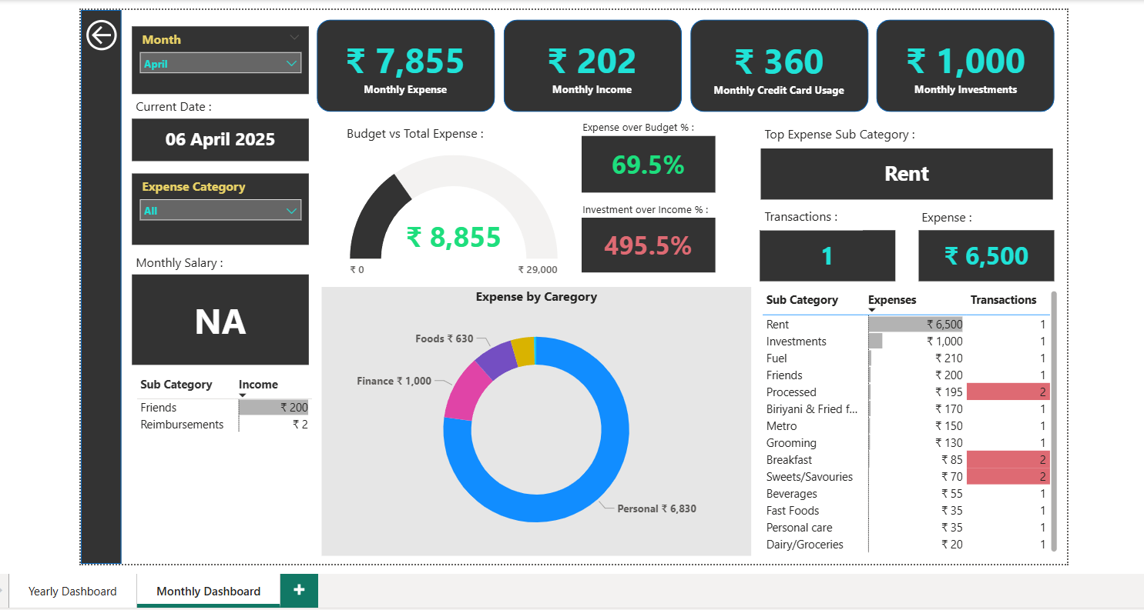

**Conclusion**

Personal finance awareness is an important aspect for any person who earns and spends. As money plays a major role in our livelihood, we clearly need to have an understanding and control over it. To achieve this, first, we need to see through our daily transactions and gain insights from our money habits.

I have a passion for collecting data. I started recording my income and expenses from 2019. It started as a data collection activity, but later I used the data to understand my spending habits and my history with money. Google Sheets helped me in recording my day-to-day expenses easily as it was accessible on my phone. I created a basic structure for recording my expenses.

As years went by, I understood the importance of data analysis in any stream. I started exploring tools that help in data analysis. I developed my interest in Power BI and started learning it. Initially, I created a dashboard in Google Sheets. With the Google Sheets dashboard as a reference and the skills I gained in Power BI, I created my Personal Finance dashboard.

The dashboard I created in Power BI is highly interactive and helps me understand my expenses within different filter contexts. The dashboard has provided me with insights in many areas, as mentioned below:

* My account balances and total expenses gave me an idea of my overall spending. It also helps me keep my expenses in check relative to my income.
* I have planned a budget for each category, and the gauge charts help me track and reduce my expenses before reaching the set target.
* My investments over the months have increased by 4%. The total investment and target visual helped me clearly understand my investment goals.
* My transport expenses kept increasing over the months. I reviewed my data and understood that I had been travelling a lot lately. Understanding the circumstances, I decided to reduce my transport expenses.
* My processed food intake was in check over these months. I plan to maintain this trend.
* ... more insights.

Since this is my personal finance story, I would not like to disclose much but would like to state the fact that this dashboard has significantly improved my understanding of my spending habits and helped me keep track of them. In this process, I have also learned the skills to collect data, structure it, clean, transform, and process it for analysis. I have also learned to select the right kinds of visuals for better data representation to provide better insights.

I would like to learn more with Power BI and use the skills learned and the Power BI tool to build more sophisticated yet simple-to-understand dashboards on multiple datasets.